**PROGRAM- 3**

**Use an appropriate data set for building the decision tree (ID3) and apply this knowledge to classify a new sample.**

1.importing database

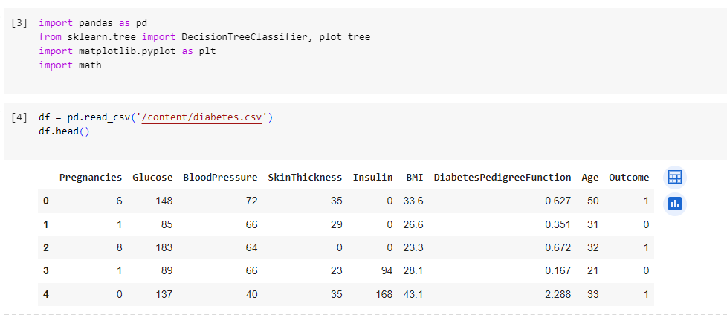

2.Calculating entropy and information gain.

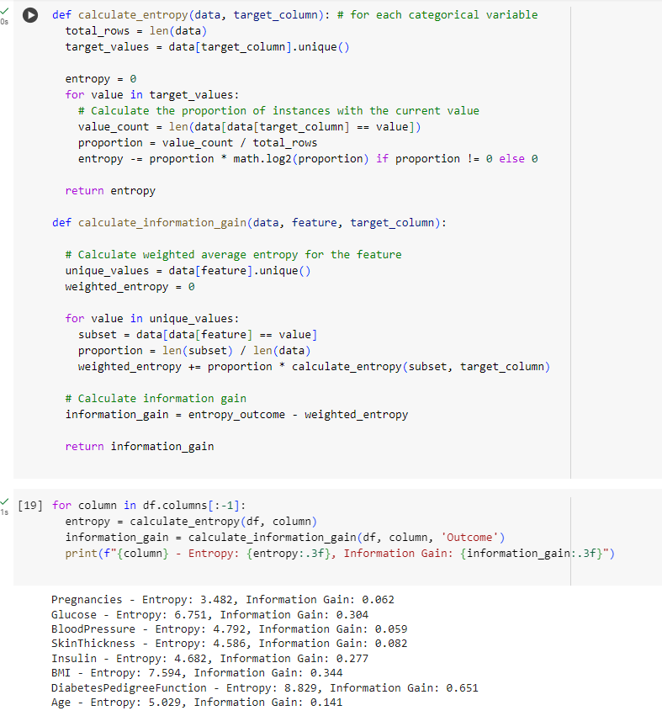

3.Making Decision tree.

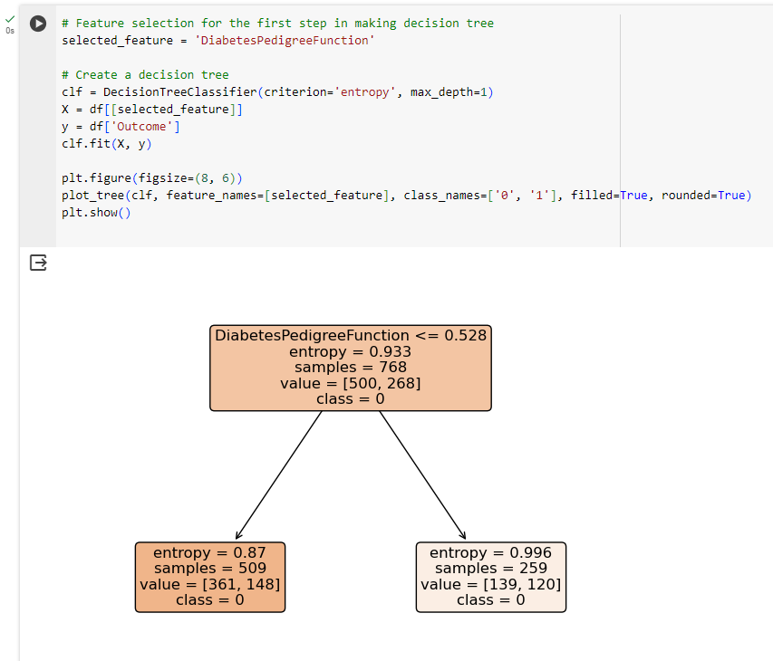

4.snapshot.





